Date: February 1, 2016

To: C-BETA Collaboration

From: BNL PI Dejan Trbojevic

Subject: C-BETA Project Planning

Below is a summary of the status of the project and set of our near term plans.

Introduction: The Cornell-Brookhaven –Electron-Test-Accelerator (C-BETA) is an Energy Recovery Linac combined with Non-Scaling Fixed Field Alternating Gradient (NS-FFAG) in a racetrack. The NS-FFAG principle is based on very strong alternating focusing with linear magnetic fields. The NS-FFAG arcs are added to the existing 7 MeV injector, a 61 MeV superconducting linac and a beam dump. Electrons are accelerated from 67 MeV up to 250 MeV by passing four times through the linac. As they pass through the linac they are transported back to the linac by a single NS-FFAG beam line. Four additional passes through the linac with an opposite phase recover the electron energy. The linac is connected to the FFAG arcs on each side with spreader/combiner beam lines. The NS-FFAG arcs are capable of transporting electrons with four energies of 67, 128, 189 and 250 MeV. Two sections of the arcs gradually transition four orbits into one orbit and continue through the straight section as shown in Fig. 1, Fig. 2, and Fig. 3.

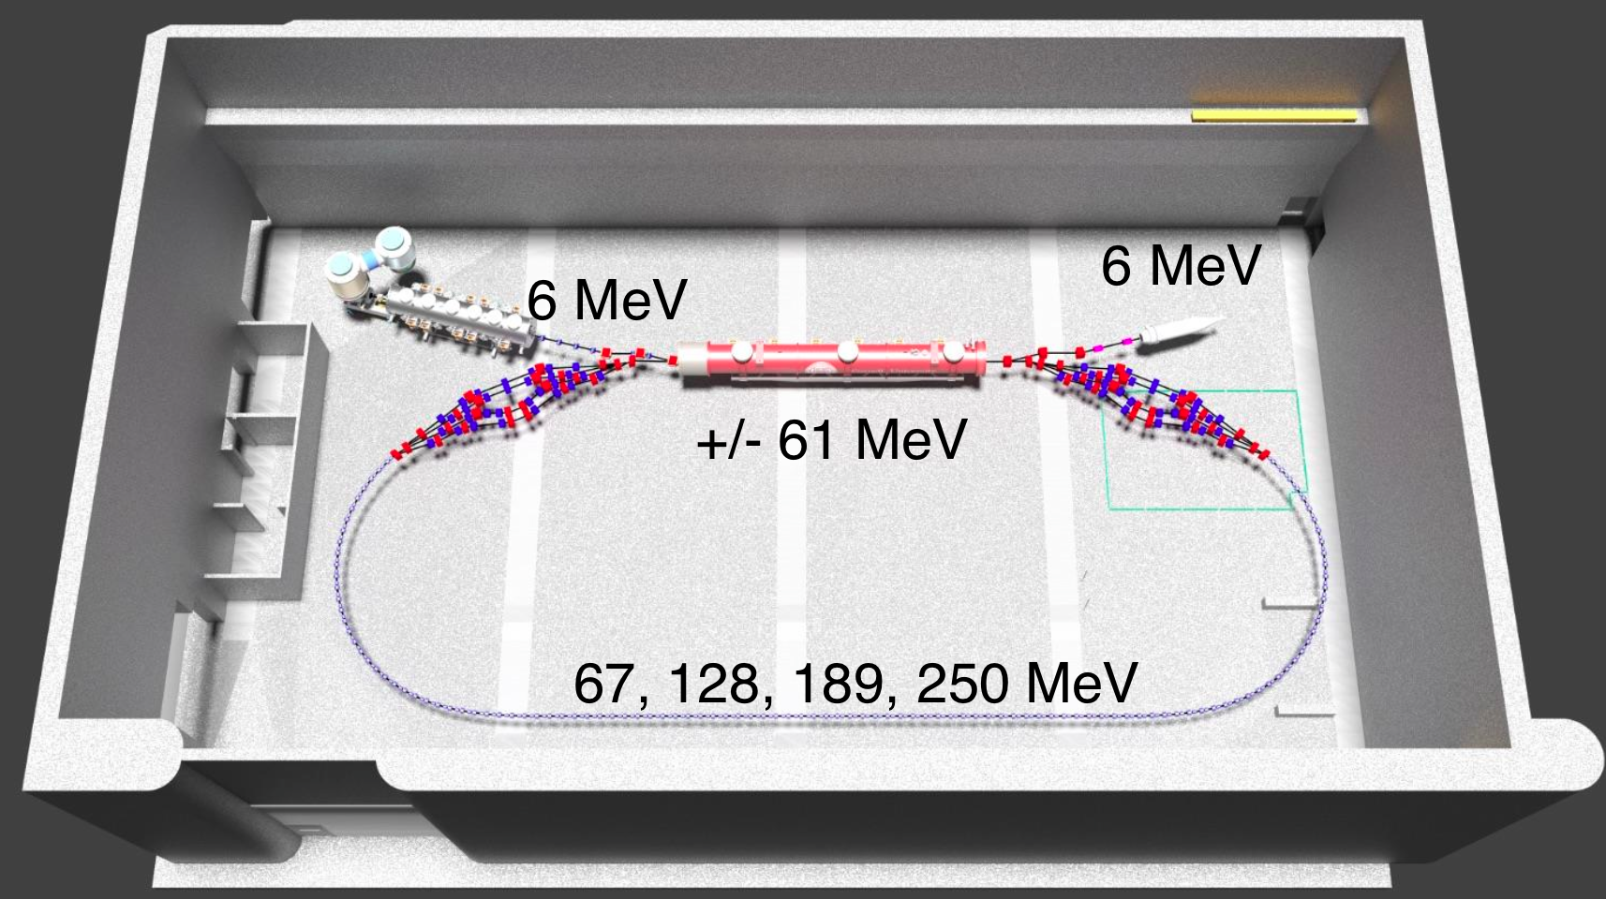
Fig. 1: Layout of the c-beta ERL accelerator with injector, linac, dump, splitter and combiner, NS-FFAG arcs and the straight section.
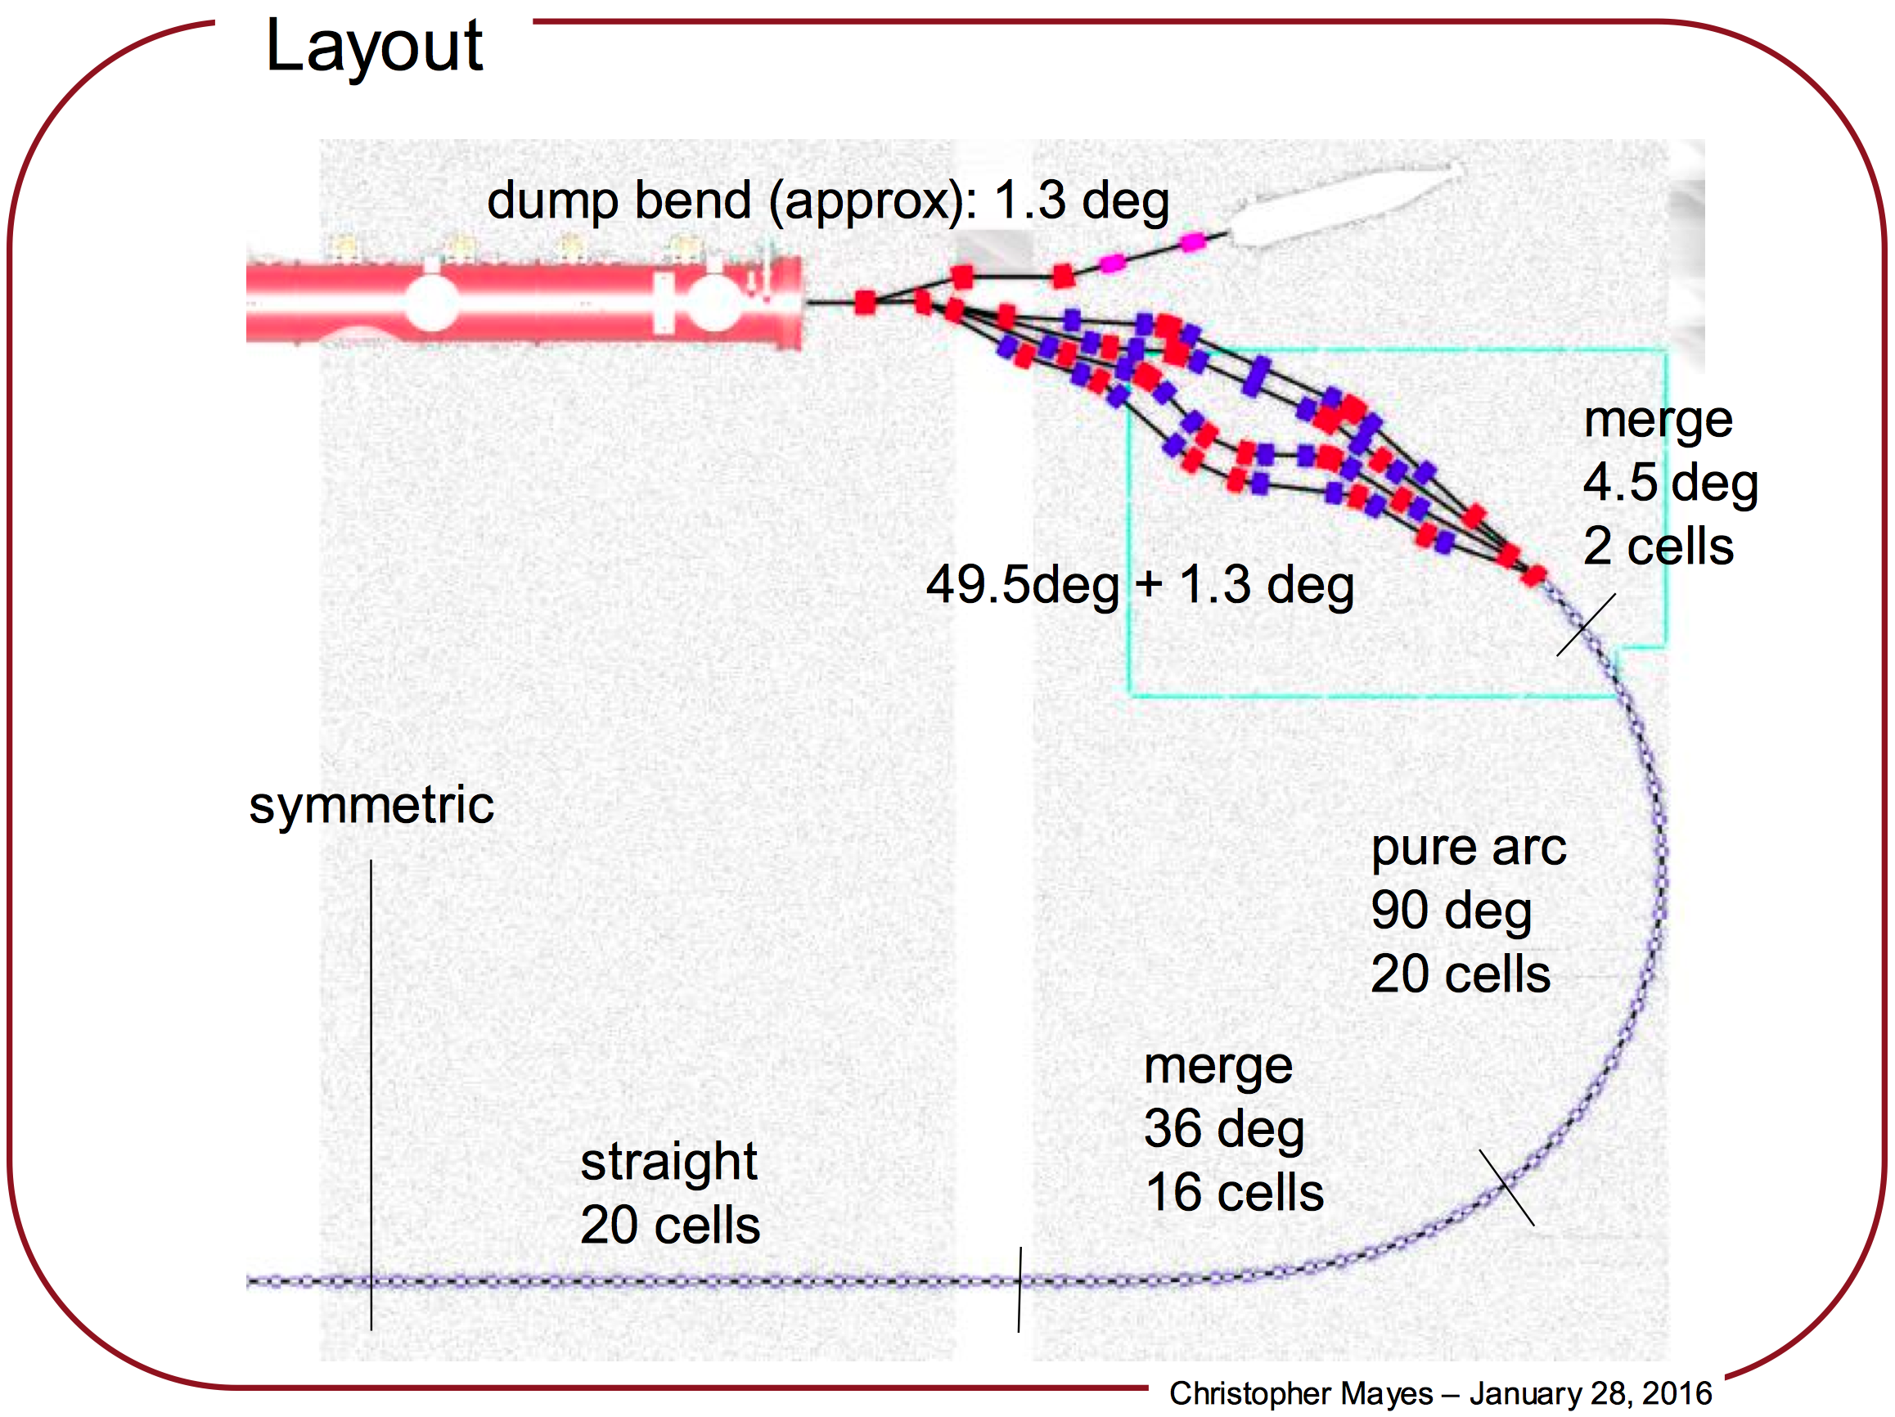
Fig 2: Linac, spreader, NS-FFAG arc, merging 16 cells, and the straight section.

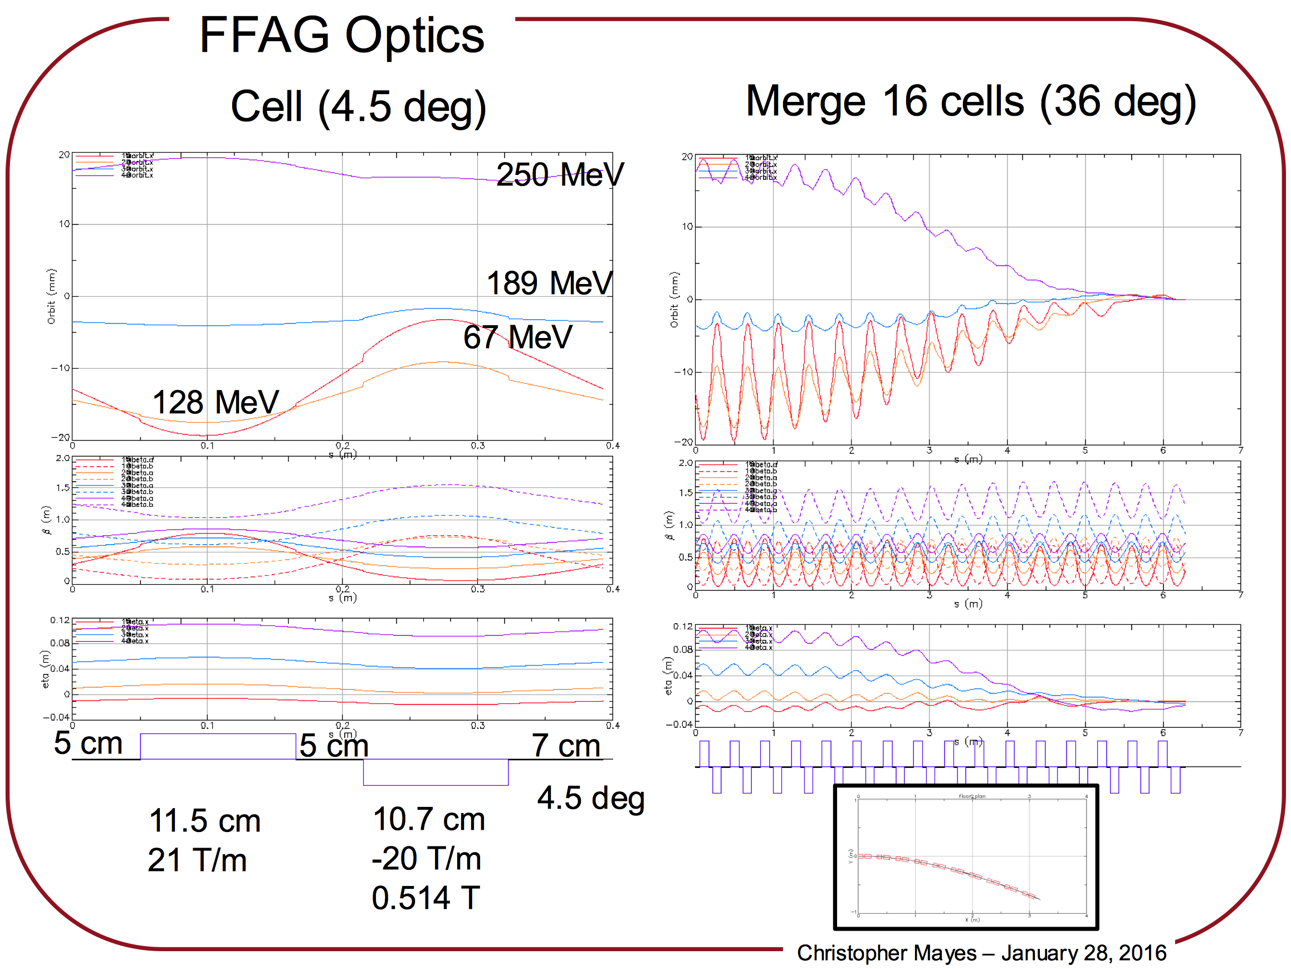
Fig 3: Orbits in the single cell (upper left), merging orbits towards the straight section (upper right), twiss and dispersion functions in the cell (lower left) and dispersion in the merging cells (lower right).
1. Magnet selection
The radius of the NS-FFAG arcs is only r~5 m and the magnets are close to each other with the drift sizes of 5 and 12 cm. Electrons oscillate with orbit offsets between the lowest (67 MeV) and the highest energy (250 MeV) within a range of ±19 mm. It is important to emphasize that the magnet field quality has to be correct for each orbit (orbits are shown in Fig. 4 and Fig 5).
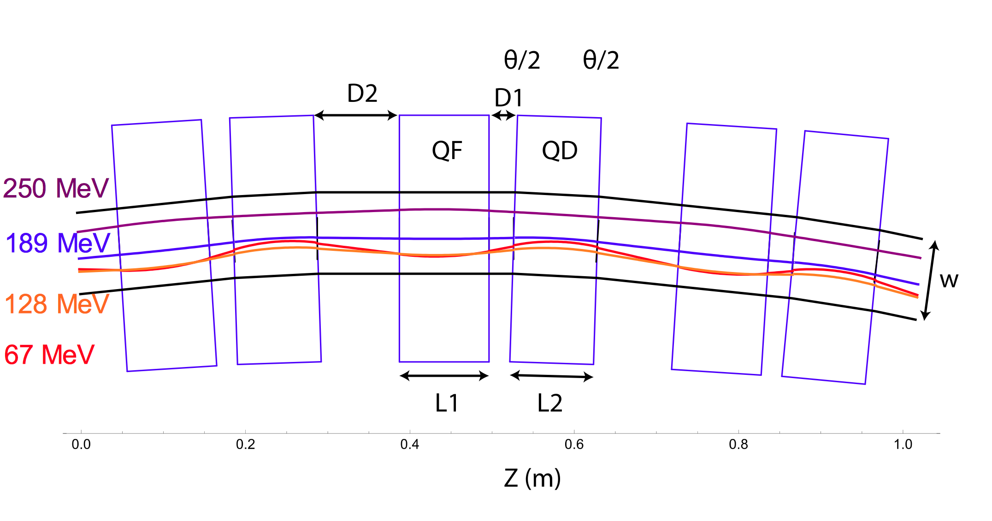
Fig. 4: Electron orbits of different energies in the three cells.

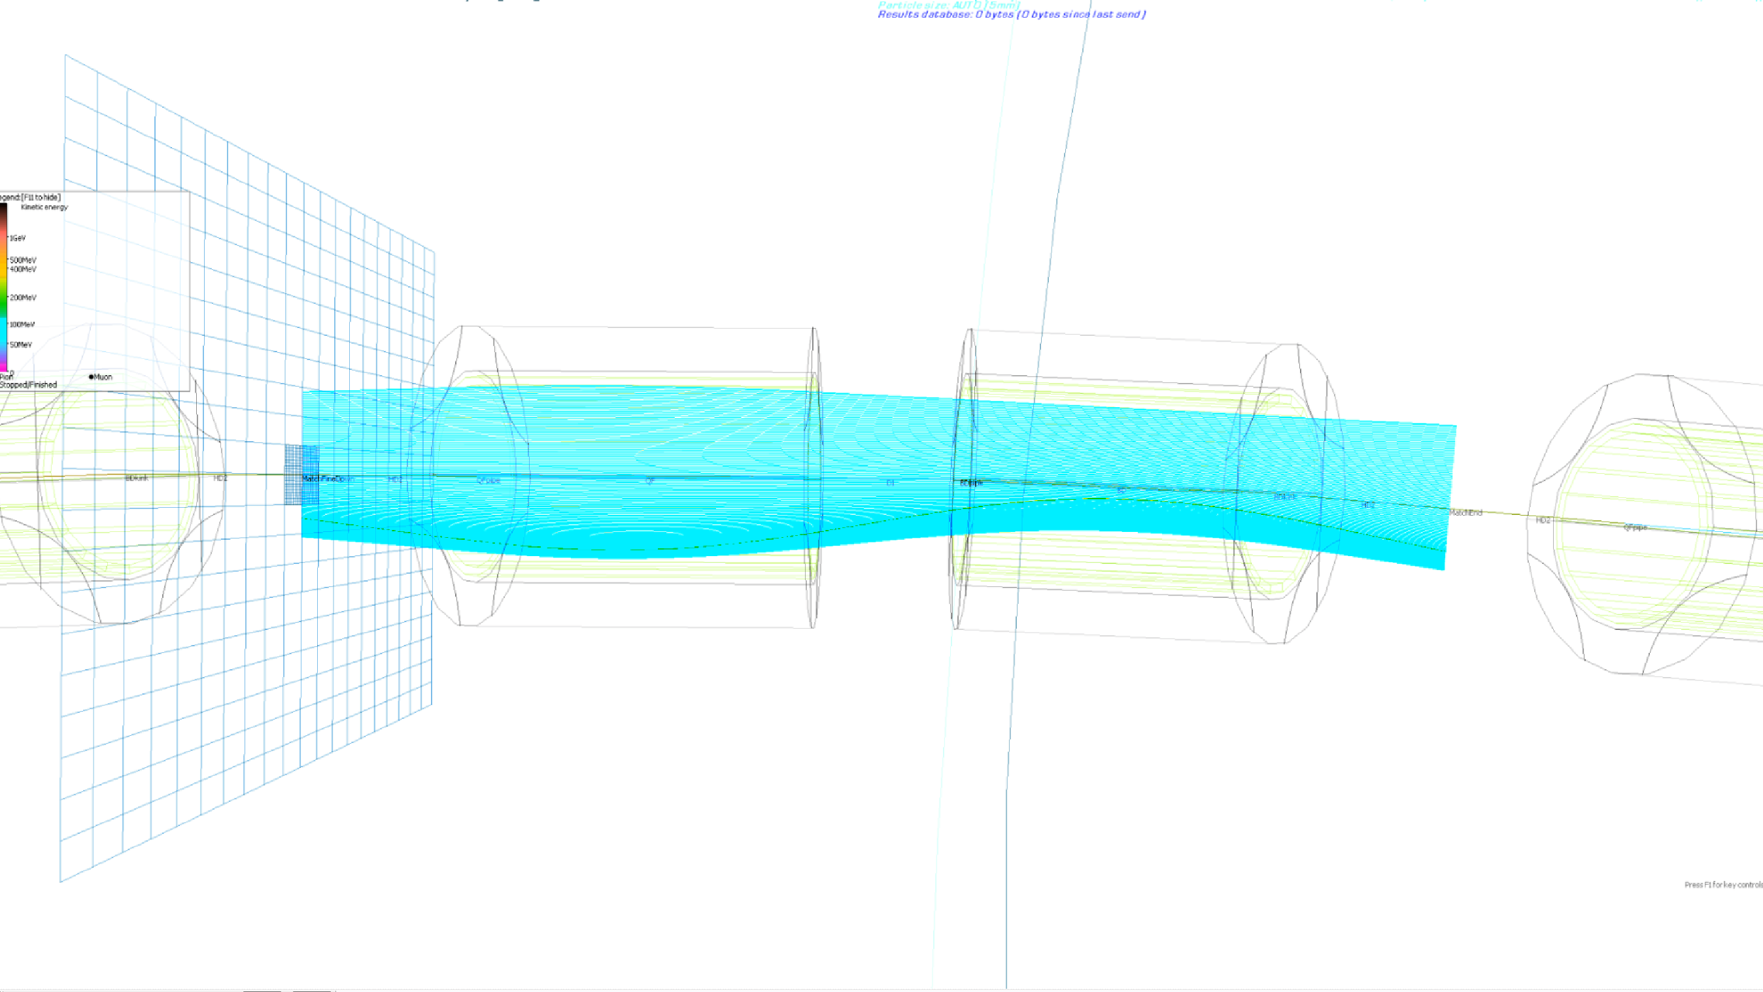
Fig. 5: Orbits obtained by tracking the beam through the 3D OPERA field maps.

The three dimensional magnetic fields, obtained by the OPERA 3D program agreed with the magnetic measurements (measurements performed by Animesh Jain at BNL). There are two combined function magnets: one with a strong quadrupole field and a small dipole field, and the other with a strong dipole field and smaller defocussing quadrupole field. The focusing magnet is very similar to the pure quadrupole but with a small radial shift. The defocusing magnet is very difficult to produce by shifting the pure quadrupole, as the required radial shift is large. The quality of magnetic field needs to be correct for ±19 mm orbits inside of the defocusing combined function magnet.
Two magnet designs are currently under consideration:
- Iron dominated quadrupole with permanent magnet material with a radial shift, and Halbach type magnets made fully of the permanent magnetic material. The iron dominated combined function magnets have also temperature compensation. The radially shifted iron dominated quadrupoles showed two problems: the quality of the magnetic field in the defocusing combined function case was not correct (as shown in Fig. 8) for all electron orbits and the magnetic field lines from one magnet affected the magnetic field of the other magnet as shown in Fig. 6 and Fig. 7.
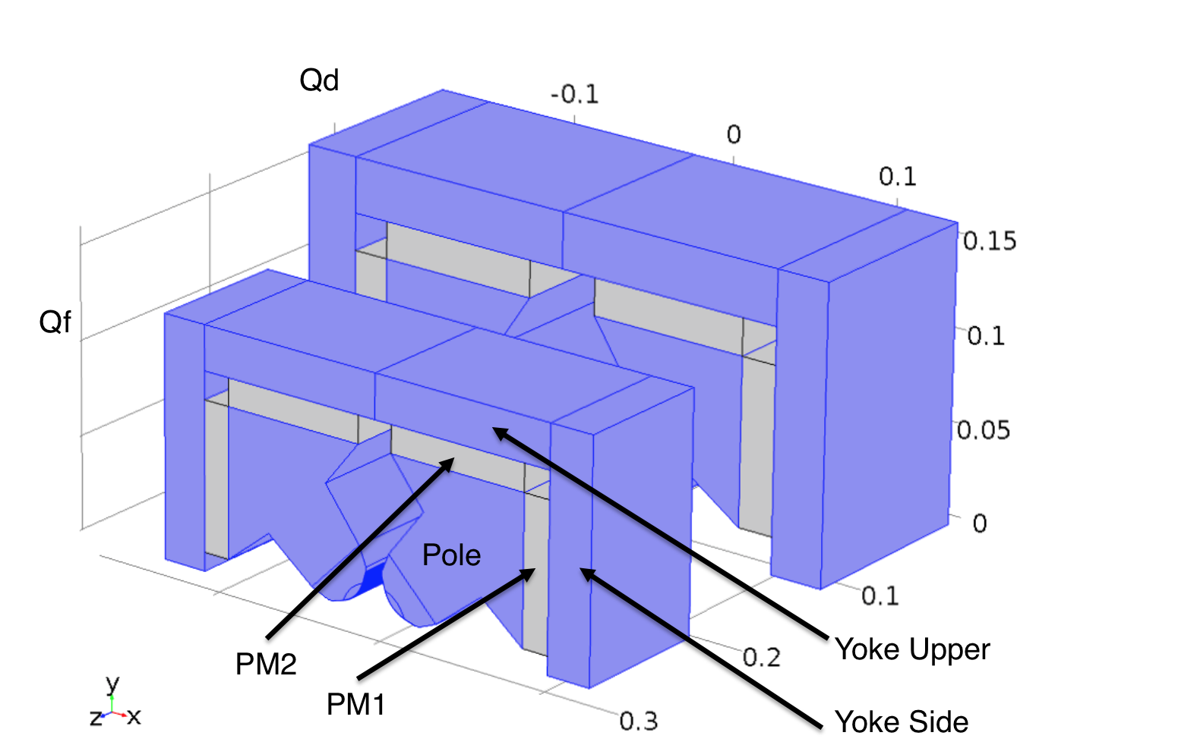
Fig. 6: Two iron dominated quadrupoles.
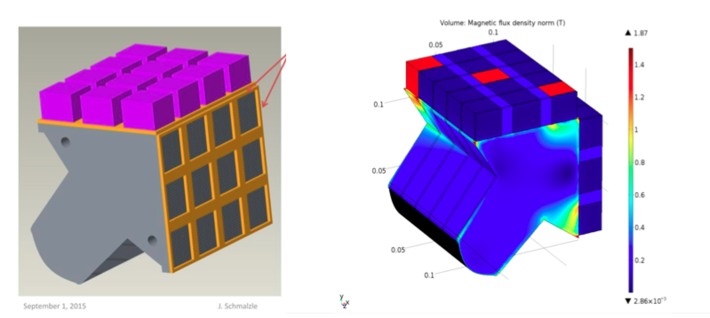
Fig. 7: A quarter of the iron dominated magnet.
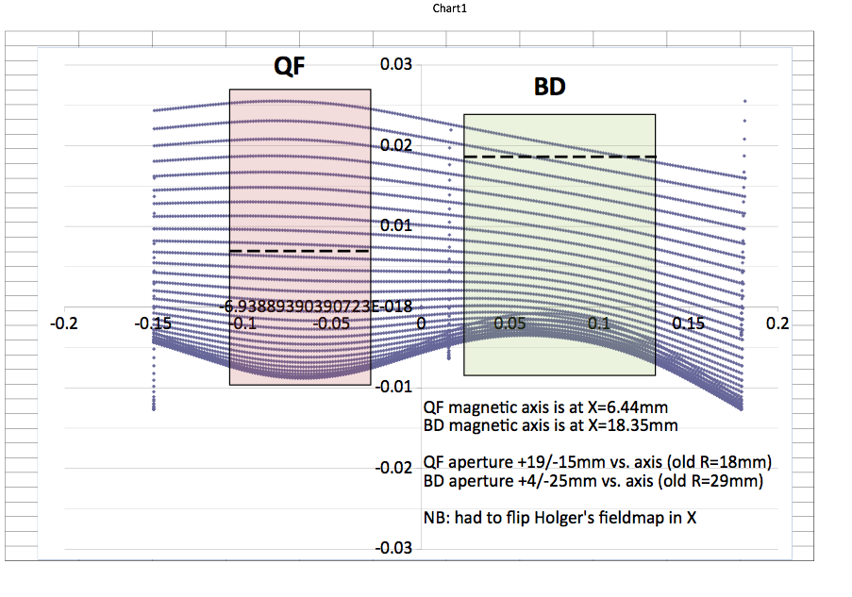
Fig. 8: Orbits and the two iron dominated quadrupoles with their centers shown by the dashed lines. Orbits are obtained by tracking through the 3D field maps.

B. The Halbach type focusing combined function magnet are made from the Halbach quadrupole made of 12 equally shaped prisms as his original design. The magnetic field is contained within the quadrupole with small end fields. The defocusing combined function magnet was first obtained by using superposition of two: quadrupole Halbach magnet surrounded by the Halbach dipole 12 pieces, providing good quality magnetic field within the orbit offset. The asymmetric Halbach magnet, a new invention, produces the high quality magnetic field in the middle of the aperture with small end fields (as shown in Fig. 9 and Fig. 10 ).
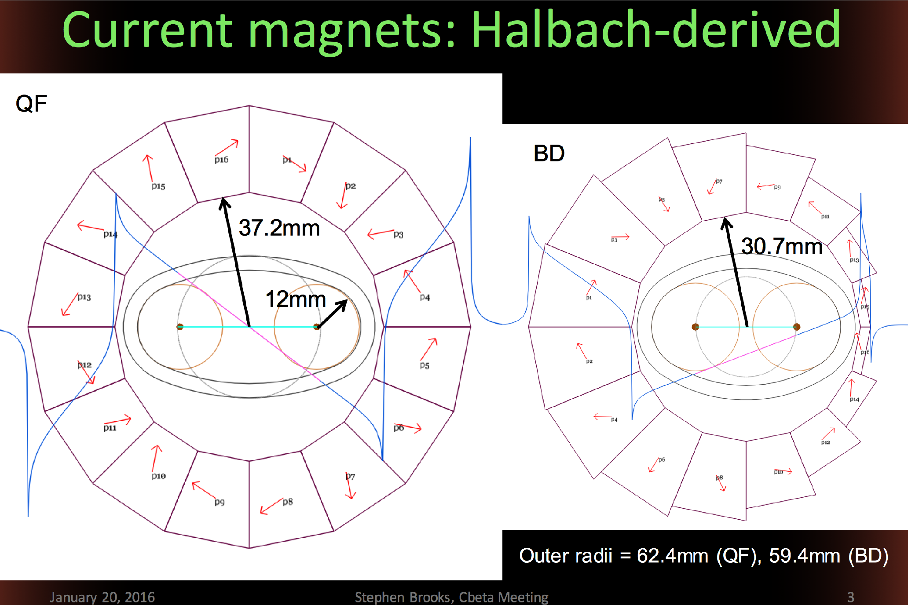
Fig.9: Modified Halbach design of the focusing (left) and defocusing (right).
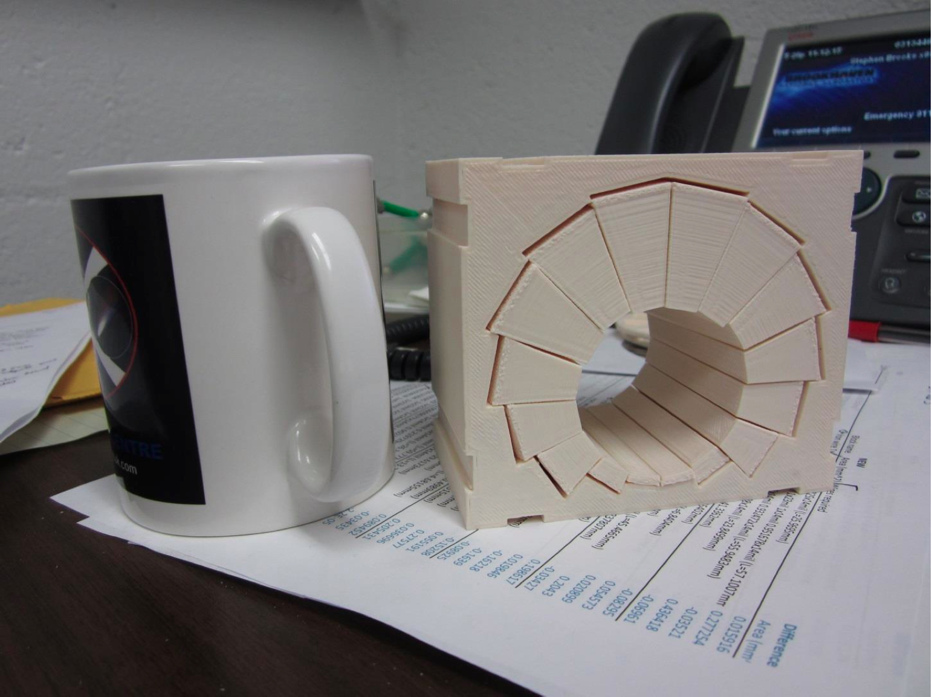
Fig. 10: A model of the combined function magnet made by the 3D printer.

As the magnetic field is contained inside of the magnet there is no interference between the neighboring magnets. The relative permeability of the Neodymium permanent magnet is very close to unit μ/μ_{o}=1.05. This allows placement of the corrector magnet iron core around the Halbach magnet without affecting the magnetic field inside the magnet, while with the current through the corrector coils the total field is a superposition of the two fields. The most important results from already built eRHIC prototype five Halbach magnets are that the predictions of the OPERA 3D magnetic field are confirmed from the measurements as shown in Fig. 11.
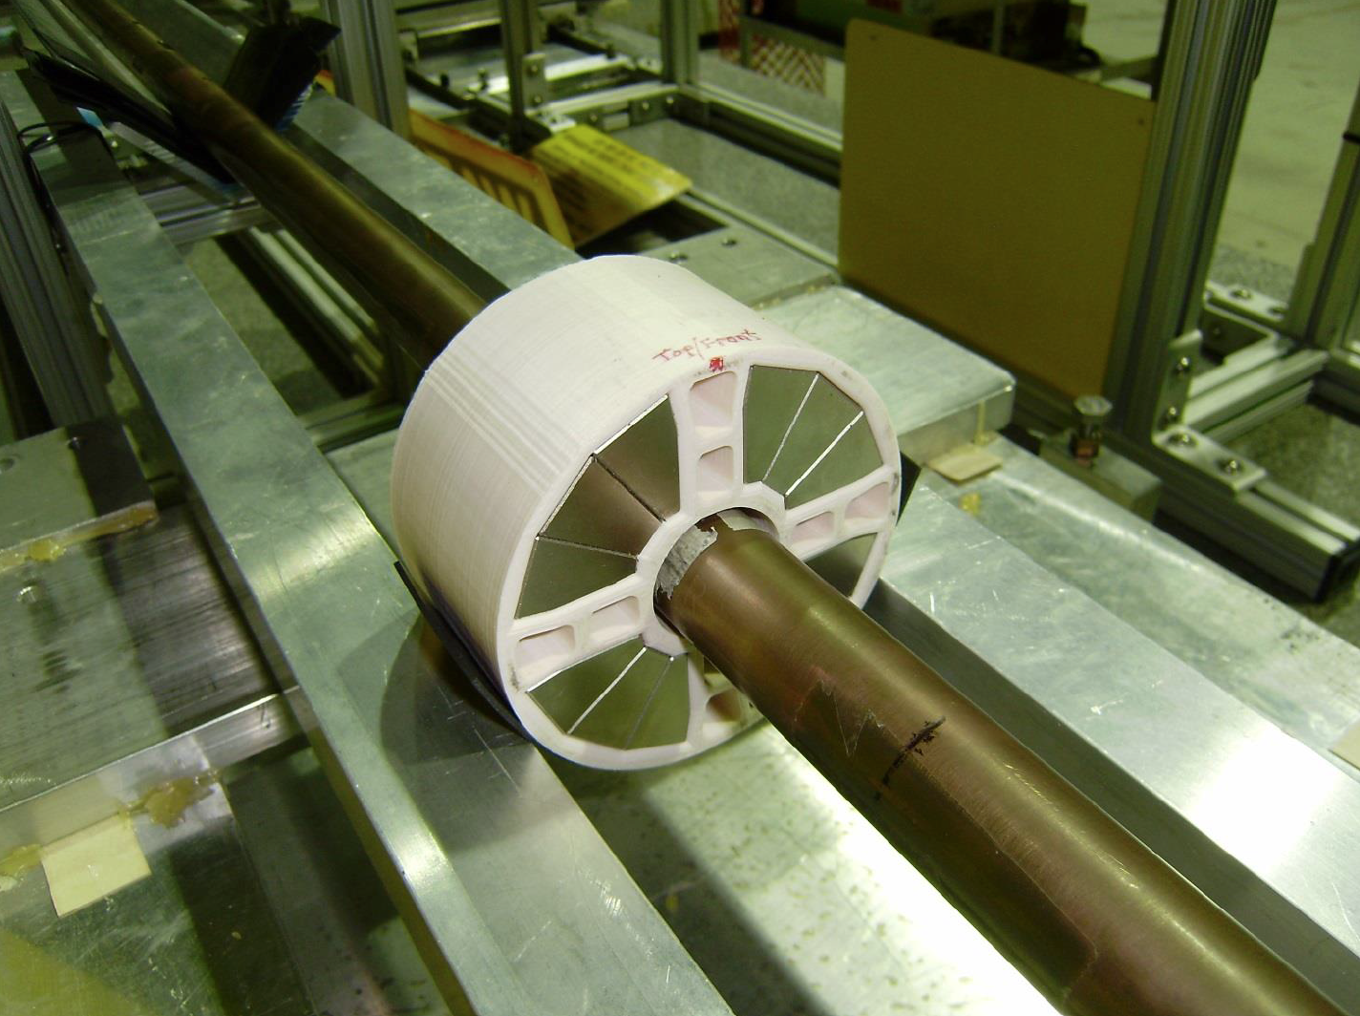
Fig.11: Rotating coil measurements of the eRHIC Halbach prototype magnet.
Table 1: The measurement results of the magnet before and after the corrections

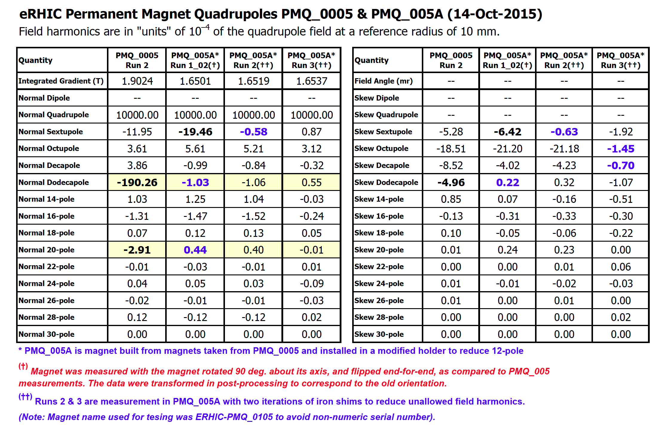
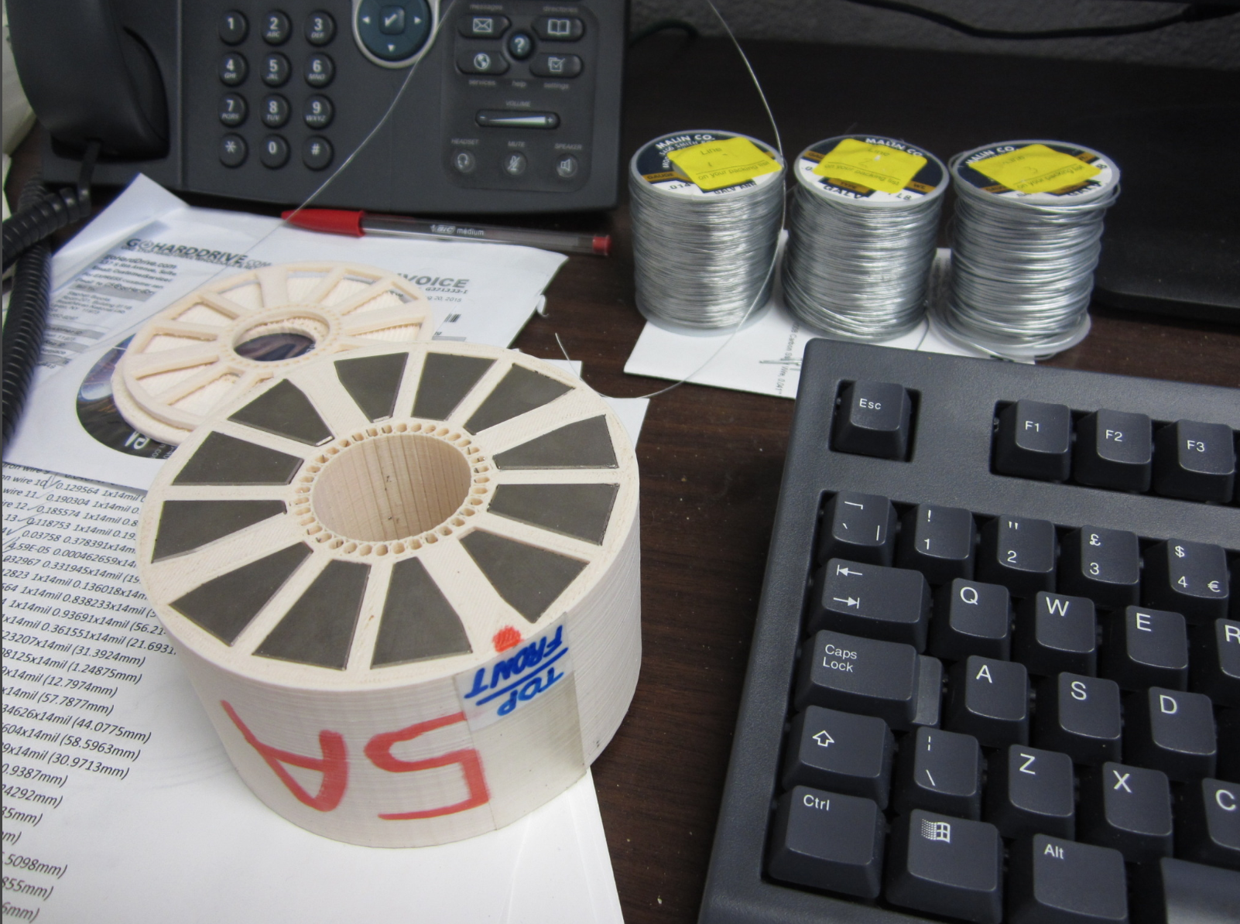
Fig. 12: Halbach eRHIC prototype magnet with correction wires.

In addition, the measured sextupole component of -19.46 units and skew octupole of -21.20 units in the initial Run 1_02, were reduced to 3.12 units or less in all multipole harmonics by Run 3 (see table 1), by placement of thin iron wires around the central magnet bore as shown in Fig. 12. The unit for this magnet is defined as 10⁻⁴ of the quadrupole field at the radius of 10 mm. This was accomplished. (There was also an initial manufacturer mistake which introduced a twelve pole of -190.26 units, which was fixed first by displacing the blocks.)

2. Current Status and Magnet Decision Process

Both designs are being taken to the prototyping stage, so a final choice will not be made until both prototypes’ performance and field quality has been measured (this is expected during May 2016).

Currently the Halbach-style magnet is the baseline as these magnets have been shown (in OPERA-3D models) to be able to provide the field strength for the FFAG arcs at 250MeV, in addition to the shimming work and good correspondence between simulations and measurements of a real Halbach quadrupole discussed in the last section.

Work is underway to see if the iron magnet design can be used with a modified lattice. Initial attempts to use the iron magnet’s fieldmaps found that the beam closed orbits could go through the iron magnet but there was not enough space between the orbits and the iron poles (less than 6mm) to fit a vacuum chamber and allow enough space for orbit errors during commissioning. The Halbach designs presently allow 17mm of space here. Early results with modified lattices and larger pole apertures suggest ~15mm may be possible with iron magnets. This should be enough, so the magnet is still under consideration and prototyping will continue.

Field quality throughout the beam excursion range is important for reducing orbit errors on each of the FFAG beams. The field quality of the Halbach magnets will be similar to the results in Table 1 (after shimming). The field quality of the iron-poled magnets is mainly determined by the quadrupole-shaped pole, which is conventional technology, albeit a smaller aperture and higher gradient than usually encountered, so it is should be measured for our case with the prototype.

Both magnet styles need to be split into top and bottom halves and reassembled in order to fit around the vacuum chamber. This could introduce random position errors that feed into the nonlinear field errors. This reassembly and measurement afterwards will also be part of the prototype measurement series. Both magnets could be prone to reassembly errors because the locations of the critical pieces (permanent magnet blocks for Halbach and the pole surfaces for iron quads) are only of the order of ~3cm away from the beams. 10⁻⁴ of this distance is 3 microns, suggesting unit errors can be visible for displacements of this order of magnitude. In the Halbach design, the transverse misplacement of top and bottom halves can produce sextupole and higher errors. In the iron design a transverse misplacement would result in asymmetrical poles, which would also produce nonlinear field errors.

3. Correction Magnets
The correction system is of critical importance of this project as errors due to misalignment, magnetic and gradient field errors have to be corrected to allow for stable orbits of all energy range.
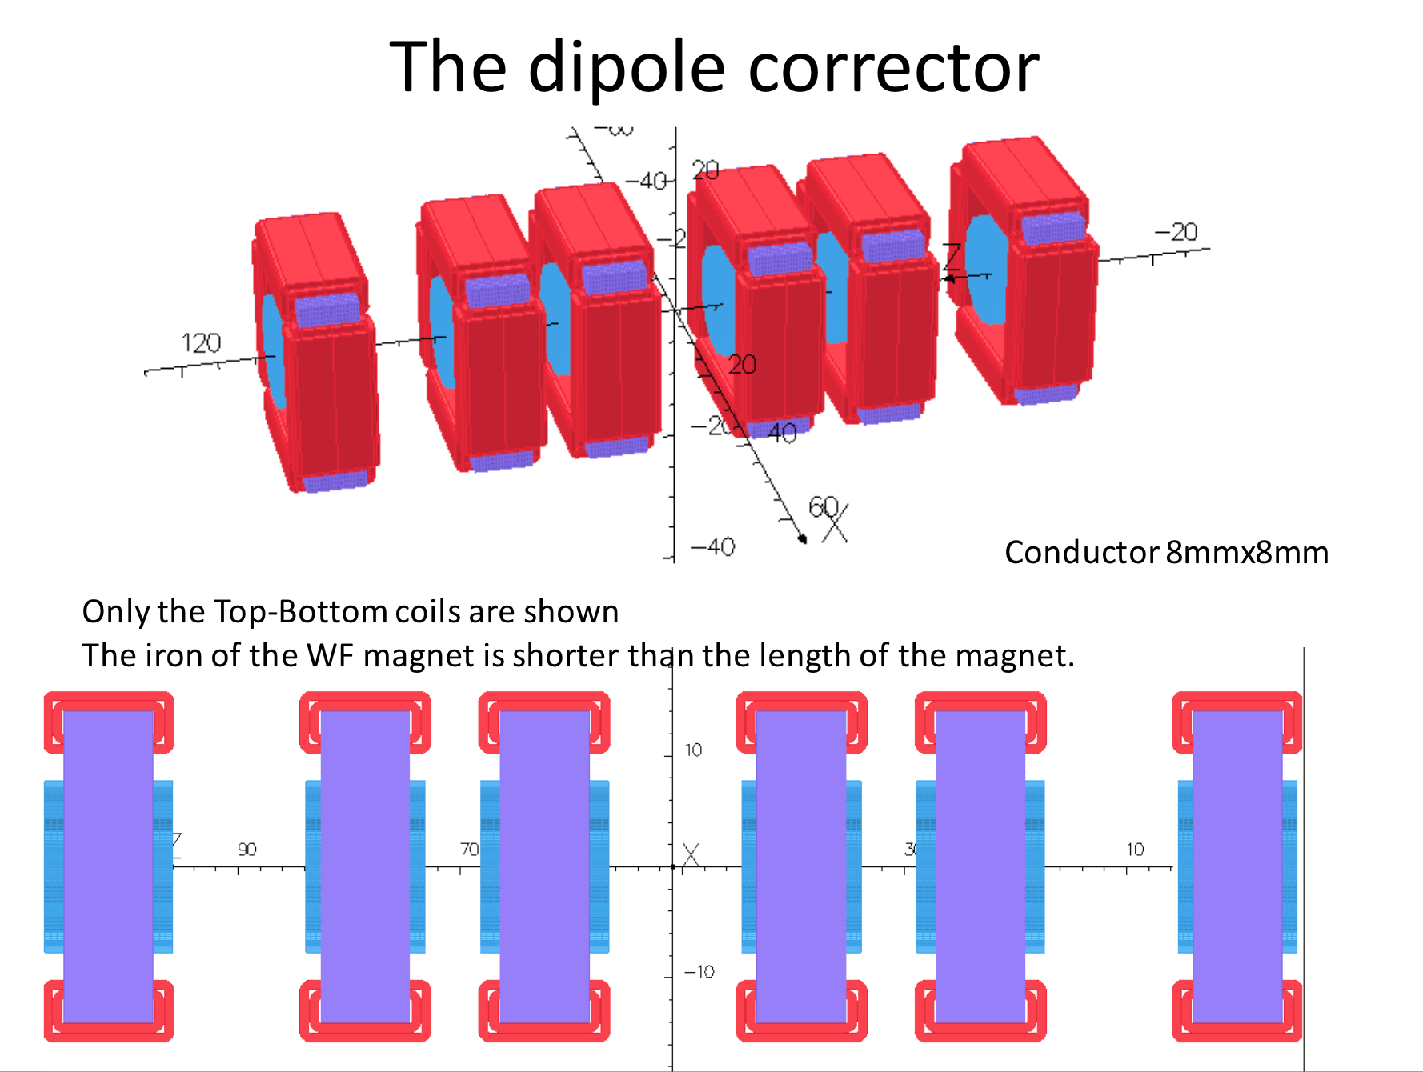

Fig. 13: Six-correction magnets place around the Halbach magnets.

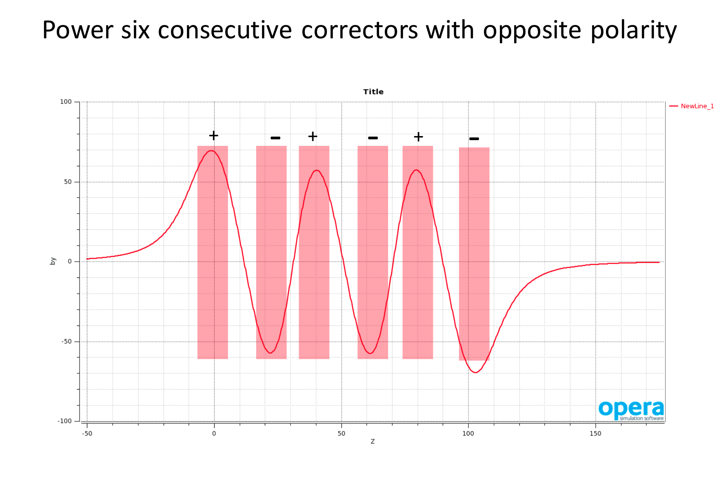
Fig. 14: OPERA 3D fields maps with correctors of opposite polarity.

At our latest collaboration meeting on Thursday, January 28, 2016 we have made a choice between the two options: the first magnet design of the Halbach type has the smallest outside radius of ~6 cm, and the smallest volume of the permanent magnet material but requires the corrugated beam pipe; the second, also Halbach type magnet design has larger outside radius of ~8cm, but the vacuum pipe is common for both focusing and defocusing magnets.

Few final steps to complete the lattice design: explore the tune space to be able to adjust the tunes of the NS-FFAG not to have 1/3 integer close to the operating point. Finish the study for a size reduction of the splitter and combiner, decide on the number of cells for the girder, do the error analysis finding the successful orbit correction with smaller number of correctors.

